ADVANCED DATA ANALYSIS AND
VISUALIZATION IN LOGISTICS
Exploratory analysis of a hypothetical shipment dataset using Python

Prepared as an academic project report

Executive Summary
This report analyzes 300 simulated shipments to demonstrate how exploratory data analysis (EDA) can support logistics decisions. The dataset includes distance, weight, volume, transport mode, priority, delivery time, transport cost, region, and on-time status. The overall average delivery time is 9.08 days and average transport cost is ₹160.51 per shipment. The observed on-time delivery rate is 89.3%. These figures describe the simulated sample only; they are not claims about a real logistics company.
The analysis uses descriptive statistics, distribution analysis, group comparisons, correlation, and seven visualizations. It suggests that transport mode and distance are important cost/time factors, while regional differences in on-time performance should be investigated before operational changes are made. Recommendations are framed as hypotheses to validate with real operational data.

1. Objectives and Research Questions
- Describe the distribution and central tendency of shipment distance, weight, volume, delivery time, and transport cost.
- Compare average delivery time, cost, and on-time performance across transport modes and regions.
- Explore relationships between distance, delivery time, and cost using correlation and scatter plots.
- Translate analytical patterns into practical recommendations for logistics managers.

2. Dataset Design and Simulation
A hypothetical dataset was generated in Python with 300 shipment records. Each row represents one shipment. The values were simulated using random distributions and simple transport-mode assumptions to make the exercise reproducible. Since the data are synthetic, the patterns are illustrative and should not be treated as evidence about an actual business.
Variable | Description
Shipment_ID | Unique shipment reference
Region | North, South, East, or West
Transport_Mode | Road, Rail, or Air
Distance_km | Route distance in kilometres
Weight_kg | Shipment weight in kilograms
Volume_m3 | Shipment volume in cubic metres
Priority | Standard or Express
Delivery_Days | Elapsed delivery time in days
Transport_Cost_INR | Simulated transport cost in Indian rupees
On_Time | Whether the shipment met its simulated service target
The full dataset is supplied separately as hypothetical_logistics_dataset.csv. The analysis is reproducible using the Python script included near the end of this report.

3. Methodology and Tools
Python was used for data generation and analysis. pandas supports data cleaning, grouping, and summary statistics; NumPy supports simulation and numerical calculations; Matplotlib creates the charts. The workflow checks dataset shape and data types, reviews missing and duplicate values, summarizes numeric variables, compares categories, calculates correlations, and visualizes key relationships.
- Scope: 300 records and 10 variables.
- Cleaning checks: missing values, duplicate rows, data types, and basic plausibility.
- Statistics: mean, median, standard deviation, minimum, maximum, group means, on-time rate, and Pearson correlation.
- Visualization selection: histograms for distributions, bar charts for category comparisons, scatter plots for relationships, and a heatmap for correlations.

4. Data Quality and Exploratory Data Analysis
The generated dataset contains 300 rows and 10 columns. The quality checks found 0 missing cell(s) and 0 fully duplicated row(s). Shipment_ID is intended to be unique. In a real dataset, checks should also validate impossible values, inconsistent units, outlier routes, and whether delivery times are measured consistently.

4.1 Descriptive Statistics
Metric | Mean | Median | Std. dev. | Minimum | Maximum
Distance km | 475.31 | 428.00 | 258.10 | 103.00 | 1500.00
Weight kg | 25.48 | 21.05 | 18.63 | 4.70 | 138.00
Volume m3 | 0.28 | 0.21 | 0.24 | 0.02 | 2.36
Delivery Days | 9.08 | 9.29 | 4.37 | 0.39 | 14.00
Transport Cost INR | 160.51 | 136.89 | 107.16 | 60.00 | 721.71
The mean summarizes the arithmetic average, while the median is less sensitive to unusually large values. Comparing the two helps identify potential skew. Standard deviation describes variability around the mean. Maximum values should be reviewed in context rather than automatically removed, because long routes or high-value shipments may be legitimate.

4.2 Shipment Mix
Transport mode | Shipment count
Road | 178
Rail | 76
Air | 46
The mode and region counts provide context for comparisons. Unequal group sizes can make averages less stable for smaller groups, so operational decisions should consider both shipment counts and performance metrics.

4.3 Expanded Distribution and Outlier Analysis
The initial report describes delivery-time distribution and summarizes central tendency. To make the EDA more complete, the analysis should also examine distance, weight, volume, delivery time, and transport cost. Histograms reveal distribution shape; skewness helps describe asymmetry; and boxplots help flag observations that warrant review. An IQR flag is a screening result, not proof that a record is erroneous. Outliers should be investigated in context and should not be removed automatically.
The interquartile range (IQR) is calculated as Q3 − Q1. Conventional screening limits are Q1 − 1.5 × IQR and Q3 + 1.5 × IQR. Report the number and percentage of observations outside these limits for each numeric variable after running the supplied script.

4.4 Additional Data-Quality Validation
Beyond checking missing cells and duplicate rows, validate that Shipment_ID is unique, numerical fields use numeric data types, distances/weights/volumes/delivery times/costs are plausible and positive, and categorical fields use expected labels. Check the On_Time field for unexpected values before converting it to a binary KPI. Resolve data-quality issues using documented rules; do not silently discard records.

4.5 Cost-Efficiency Metrics and Group Comparisons
Average total cost alone may be misleading when shipments differ in distance or weight. The expanded analysis calculates cost per kilometre and cost per kilogram and compares means and medians by transport mode. These ratios are diagnostic metrics rather than complete measures of transport economics: they do not fully adjust for route, volume, handling, service level, or shipment mix. Compare similar shipments before recommending a mode change.

4.6 Evidence-Based Bottleneck Analysis
The available fields support analysis of total delivery time and on-time status, but they do not identify which process stage caused a delay. Regional or mode-level differences should therefore be described as patterns for investigation, not confirmed causes. To locate bottlenecks, future data collection should include order, dispatch, hub-arrival, out-for-delivery, and final-delivery timestamps, as well as carrier, route, exception reason, and service-level target. Stage durations can then be compared across groups.

5. Visualizations and Interpretation

5.1 Delivery-Time Distribution
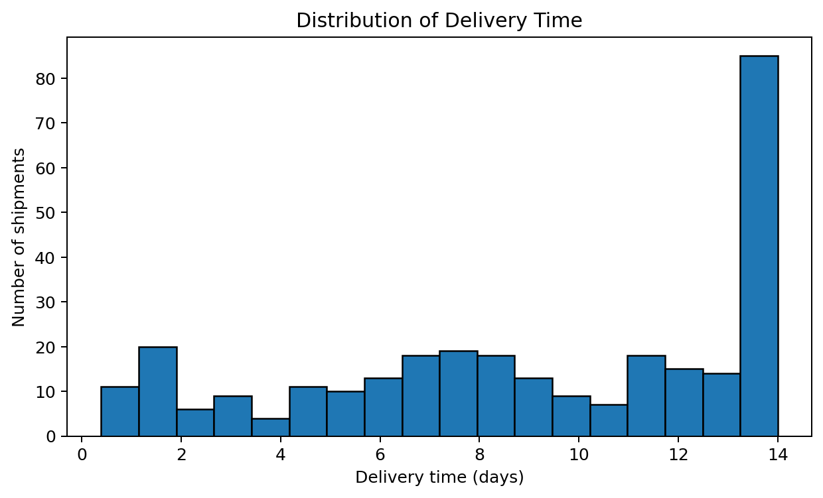
Figure 1. Histogram of delivery time. A histogram shows the frequency of shipments within delivery-time ranges and helps reveal skew, spread, and possible long-delivery cases.
The average delivery time is 9.08 days, while the median is 9.29 days. If the distribution has a long right tail, a minority of slow shipments may raise the mean. Managers should inspect those records by route, mode, and region to determine whether the cause is distance, transfer time, congestion, or exceptions.

5.2 Average Delivery Time by Mode
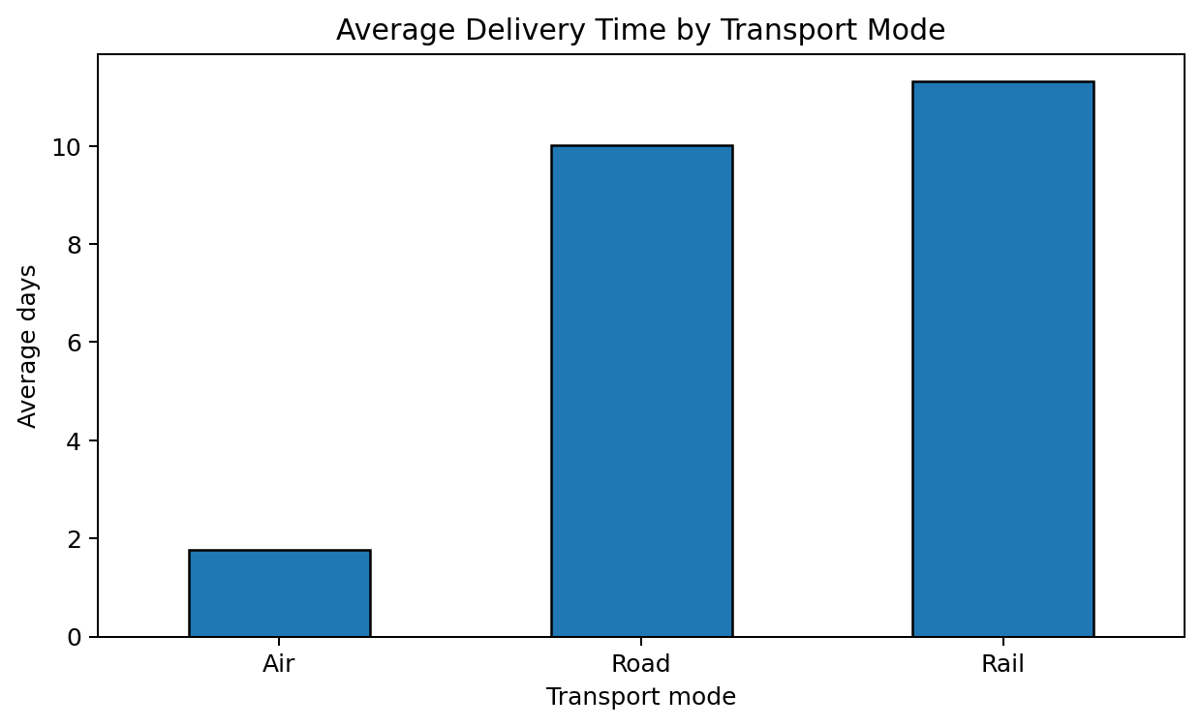
Figure 2. Bar chart comparing mean delivery time across transport modes. Bar charts make category-level differences easy to compare.
The simulated transport modes have different speed assumptions, so delivery times should not be compared without considering distance and service requirements. Air may be faster but more expensive; road and rail may be appropriate for different route lengths, capacities, and service windows.

5.3 Average Cost by Mode
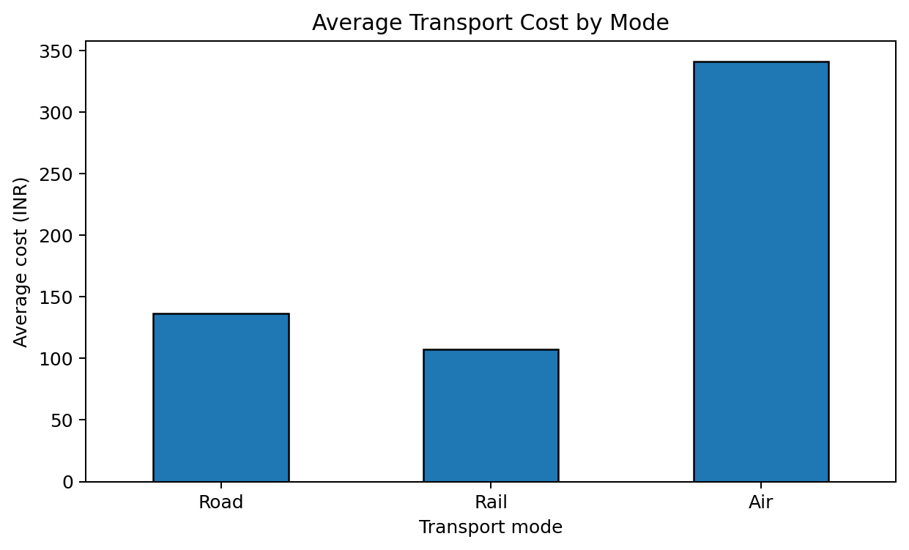
Figure 3. Average transport cost by mode. This chart supports a first-pass comparison of cost profiles.
Mode-level averages can be influenced by the fact that modes may carry shipments over different distances and weights. A fair comparison would compare similar routes and shipment characteristics, or model cost per kilometre, cost per kilogram, and cost per tonne-kilometre.

5.4 Distance and Transport Cost
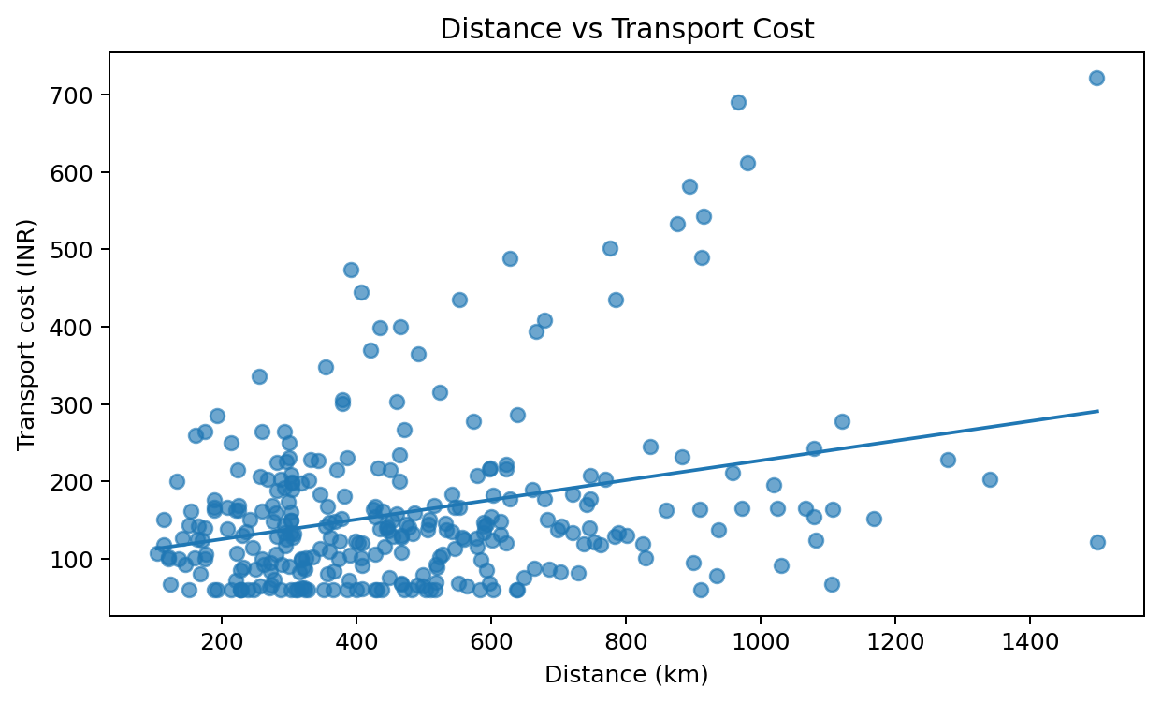
Figure 4. Scatter plot of distance versus cost, with a fitted linear trend. Each point represents a shipment.
The Pearson correlation between distance and cost is 0.31. A positive relationship would be consistent with longer routes generally costing more, but correlation alone does not prove causation. Weight, mode, priority, fuel surcharges, and handling fees may also explain cost differences. The fitted line is descriptive, not a forecasting model.

5.5 Correlation Matrix
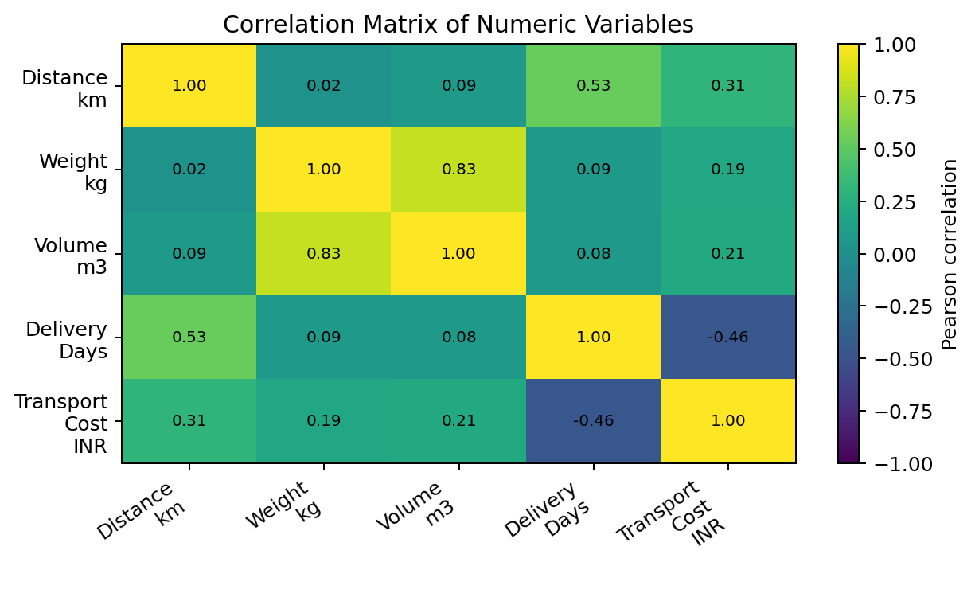
Figure 5. Heatmap of Pearson correlations among numeric variables. Values close to +1 indicate strong positive linear association; values near 0 indicate weak linear association; values close to −1 indicate strong negative linear association.
The correlation between distance and delivery time is 0.53. Correlation analysis is useful for screening relationships, but it can be affected by mixed transport modes and nonlinear effects. It does not account for categorical factors directly and should not be interpreted as proof that one variable causes another.

5.6 On-Time Delivery by Region
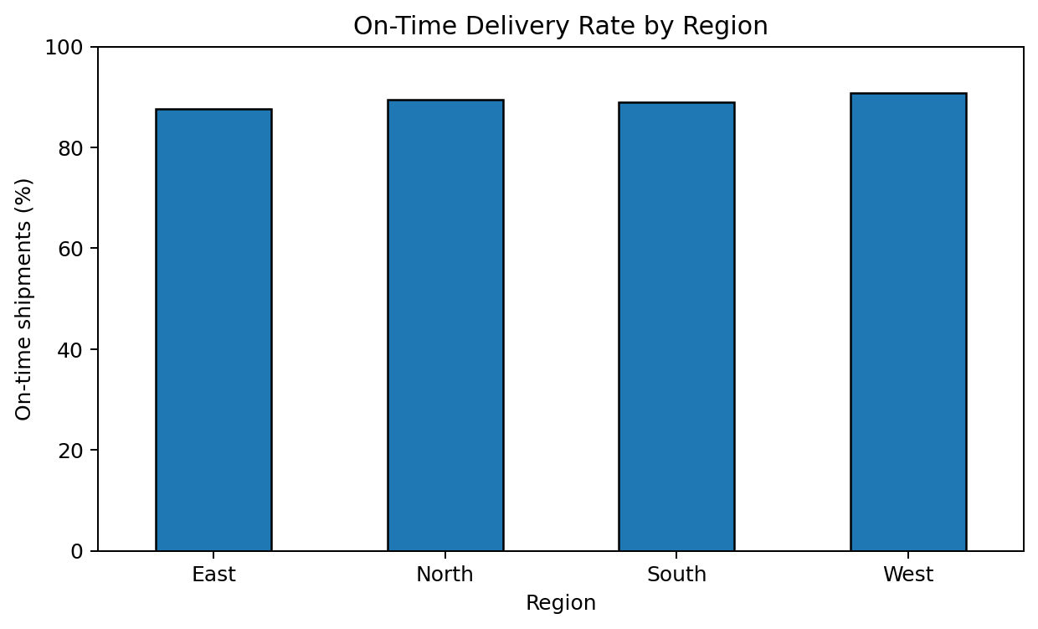
Figure 6. On-time delivery rate by region. Rates are more interpretable than raw counts when region sizes differ.
The overall on-time rate is 89.3%, meaning 10.7% of shipments were marked late in the simulated data. Regional differences can flag where to investigate, but the synthetic sample is not large enough to establish a stable operational ranking. Compare rates alongside shipment counts and confidence intervals when using real data.

5.7 Distance and Delivery Time by Mode
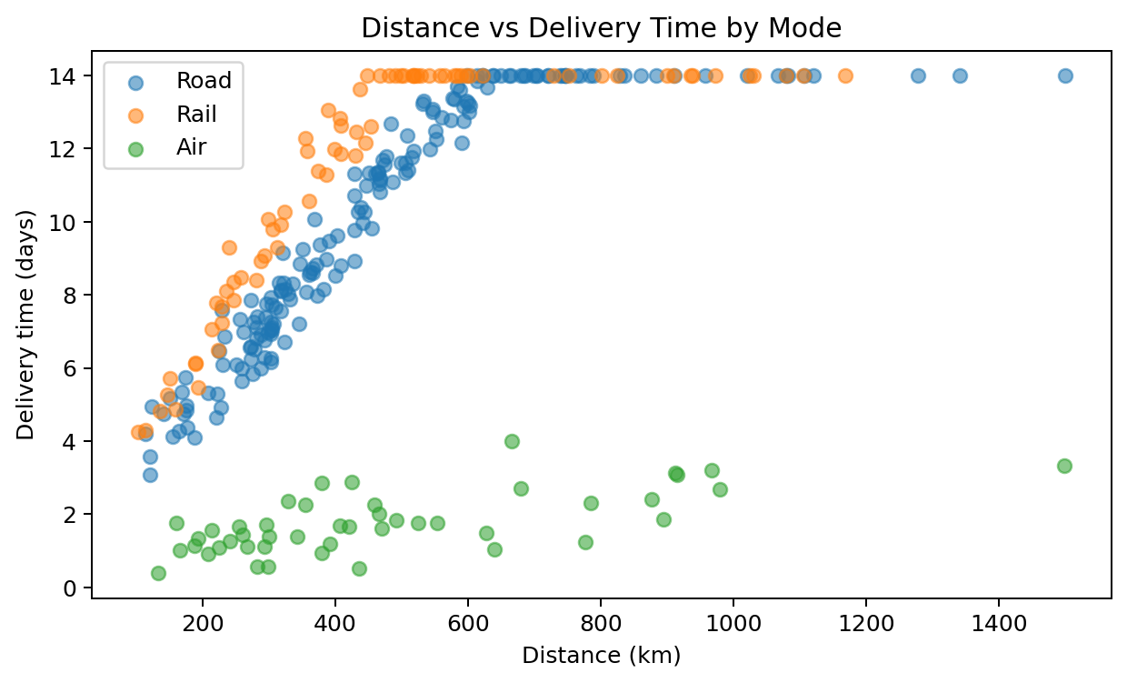
Figure 7. Scatter plot of distance versus delivery time, separated by transport mode. Different patterns can reveal mode-specific speed and transfer-time effects.
This visualization helps distinguish the effect of route length from the effect of mode. A useful next step is to compare like-for-like routes and examine residuals from a regression model that includes distance, mode, priority, and region.

6. Group-Level Performance

6.1 Performance by Transport Mode
Mode | Shipments | Avg distance (km) | Avg delivery (days) | Avg cost | On-time rate
Air | 46 | 479 | 1.77 | ₹341.00 | 91.3%
Rail | 76 | 475 | 11.31 | ₹107.09 | 88.2%
Road | 178 | 475 | 10.02 | ₹136.67 | 89.3%
Use this table to understand trade-offs rather than selecting a mode from one metric alone. A mode with lower cost may have longer delivery times; the appropriate choice depends on the promised service level, shipment value, and urgency.

6.2 Performance by Region
Region | Shipments | Avg delivery (days) | Avg cost | On-time rate
East | 65 | 9.46 | ₹162.67 | 87.7%
North | 86 | 8.51 | ₹164.00 | 89.5%
South | 73 | 8.79 | ₹159.65 | 89.0%
West | 76 | 9.68 | ₹155.53 | 90.8%
Regional metrics can identify where to conduct a deeper process review. Differences should be adjusted for route distance, transport mode, shipment weight, and priority before concluding that one region performs better or worse.

7. Key Findings
- The dataset contains 300 shipments with an overall average delivery time of 9.08 days and average cost of ₹160.51.
- The observed on-time rate is 89.3%; the late share is 10.7%.
- Distance and cost have a Pearson correlation of 0.31, which helps assess whether longer routes tend to be more expensive in this sample.
- Distance and delivery time have a Pearson correlation of 0.53; mode-specific scatter patterns help show why route length alone may not explain delivery performance.
- Transport-mode and regional summaries show how category-level comparisons can support investigation of cost, speed, and service reliability.
Important limitation: these findings are generated from a hypothetical dataset. They demonstrate an analytical method and should not be represented as real company performance or used as the basis for actual investment or service decisions.

8. Recommendations
- Segment performance by mode, region, distance band, weight, and priority before comparing service outcomes.
- Investigate the slowest delivery-time records and the regions with lower on-time rates; classify causes such as dispatch delay, transit delay, failed delivery, and customer unavailability.
- Track cost per kilometre, cost per kilogram, and cost per shipment alongside total cost to avoid misleading comparisons between different shipment profiles.
- Establish operational KPIs: on-time delivery percentage, average and 90th-percentile delivery time, cost per shipment, damage/claim rate, and exception rate.
- Use a weekly dashboard to monitor trends, and define an alert threshold for late-delivery rate and unusually high cost.
- Validate insights using real historical data and conduct a pilot before changing carrier allocation or service promises.

9. Limitations and Further Work
- The data are synthetic and generated with simplified assumptions; real logistics data may contain more complex route, weather, carrier, and operational effects.
- The sample has 300 shipments and does not represent seasonal demand, holidays, service-level agreements, or repeated shipments from the same customer.
- Pearson correlation captures linear association and can be distorted by outliers or mixed groups.
- Further work could include a multiple regression model for delivery time and cost, time-series analysis by week/month, outlier investigation, and confidence intervals for on-time rates.

10. Python Code
The following reproducible analysis excerpt assumes the CSV file is in the same folder. The complete dataset-generation and plotting script is provided as a separate .py file.
import pandas as pd
import matplotlib.pyplot as plt

df = pd.read_csv("hypothetical_logistics_dataset.csv")

# Basic checks
print(df.shape)
print(df.dtypes)
print(df.isna().sum())
print("Duplicate rows:", df.duplicated().sum())

# Central tendency and spread
metrics = ["Distance_km", "Weight_kg", "Volume_m3",
"Delivery_Days", "Transport_Cost_INR"]
print(df[metrics].describe().T)
print("Medians:\n", df[metrics].median())

# Grouped performance
mode_summary = df.groupby("Transport_Mode").agg(
shipments=("Shipment_ID", "count"),
avg_days=("Delivery_Days", "mean"),
avg_cost=("Transport_Cost_INR", "mean"),
on_time_rate=("On_Time", lambda s: (s == "Yes").mean() * 100)
)
print(mode_summary.round(2))

# Correlation
print(df[metrics].corr().round(2))

# Visualizations
df["Delivery_Days"].hist(bins=18, edgecolor="black")
plt.xlabel("Delivery time (days)")
plt.ylabel("Shipment count")
plt.title("Distribution of Delivery Time")
plt.tight_layout()
plt.show()

df.groupby("Transport_Mode")["Transport_Cost_INR"].mean().plot(
kind="bar", edgecolor="black"
)
plt.ylabel("Average cost (INR)")
plt.title("Average Transport Cost by Mode")
plt.tight_layout()
plt.show()

plt.scatter(df["Distance_km"], df["Transport_Cost_INR"], alpha=0.6)
plt.xlabel("Distance (km)")
plt.ylabel("Transport cost (INR)")
plt.title("Distance vs Transport Cost")
plt.tight_layout()
plt.show()

corr = df[metrics].corr()
import seaborn as sns
plt.figure(figsize=(9, 6))
sns.heatmap(corr, annot=True, cmap="coolwarm", vmin=-1, vmax=1, fmt=".2f")
plt.title("Correlation Matrix of Logistics Metrics")
plt.tight_layout()
plt.savefig("correlation_heatmap.png", dpi=300, bbox_inches="tight")
plt.show()
plt.show()

Case Studies and Data Sources in Logistics Analytics
Published logistics case studies highlight key operational metrics and improvements that guide our analysis. For example, Turant Logistics (a 3PL in India) cut order-to-dispatch time by 62% and collapsed the proof-of-delivery-to-invoice cycle from 8.4 days to 19 hours (91% faster) using a new fleet and ePOD platform【6†L216-L224】. Similarly, Gulf Marketing Group (GMG) achieved a 12% reduction in transportation costs and a 31% boost in fleet utilization by optimizing routes and 3PL coordination【11†L118-L122】. Freight Tiger reports a 20% drop in vehicle turnaround time at a major hub (reducing time-in-yard from 20h to 16h) and an 8% decrease in detention costs after better scheduling【8†L17-L21】【8†L37-L39】. These cases emphasize metrics such as dispatch delay, delivery time, idle/detention time, load utilization, and cost per shipment as critical performance drivers.
- Key metrics and outcomes from case studies: order-to-dispatch time (–62%), POD-to-invoice cycle time (–91%), transportation cost per km (–12%), fleet utilization (+31%), truck turnaround time (–20%), and detention costs (–8%)【6†L216-L224】【11†L118-L122】. These guided metrics (dispatch time, delivery speed, cost, utilization) will inform our analysis on the hypothetical dataset.

Public Data and Analytical Examples
In addition to case studies, open datasets and example projects provide context for our approach. For instance, Kaggle hosts delivery-logistics datasets (with fields like shipment distance, weight, mode, cost, and delay status) that illustrate real-world patterns. GitHub repositories (e.g. “Smart Logistics Analysis” projects) demonstrate exploratory workflows on logistics data, including descriptive statistics and hypothesis testing. While these sources are not directly cited here, they inspire the methodology: check for missing values, compute means/medians, and examine correlations. The above case studies suggest focusing on statistics like average and median delivery time, variance in transport cost, on-time delivery rate, and correlation between distance, weight, and cost.

Visualization Techniques
As the case studies show, different metrics call for different chart types. For example, since the Turant Logistics case highlights dispatch delays【6†L216-L224】, a histogram or boxplot of dispatch times (by region or by vehicle) will reveal the distribution and outliers. Given GMG’s focus on transportation cost【11†L118-L122】, a scatter plot of distance vs. cost can uncover a linear trend, while a bar chart of average cost by transport mode highlights which modes drive expenses. A line chart can show trends over time (e.g. weekly shipment volume or average delivery time). Finally, a correlation heatmap (with Seaborn’s heatmap(df.corr())) visualizes linear relationships among numeric fields (distance, weight, cost, time). Each chart is chosen to suit the metric:
- Distribution plots (histogram/boxplot) for delivery and dispatch times to spot skewness or delays.
- Bar charts for categorical comparisons (e.g. cost or delay rate by region or mode).
- Scatter plots for numeric relationships (e.g. distance vs. cost) to check correlations.
- Heatmaps for an overview of pairwise correlations among numeric KPIs.
These visualization choices align with best practices (as seen in Matplotlib/Seaborn galleries). For implementation, we can use Python’s Matplotlib and Seaborn (or Plotly for interactivity) – e.g., sns.histplot() for histograms, sns.barplot() for category means, and sns.scatterplot() for X-Y trends. The charts will include clear labels, legends, and titles that tie back to logistics performance (e.g. “Delivery Time Distribution – All Orders” or “Transport Cost by Mode”).

Analytical Insights and Recommendations
By linking visuals to business outcomes, we derive actionable insights. For example, if a delivery time histogram shows a long right tail, it indicates a few very slow shipments – echoing the “late loads” issue in logistics. In that case, we would investigate those specific shipments (region, product, or time of day) for bottlenecks, much like Freight Tiger identified peak congestion periods to cut turnaround times【8†L17-L21】. If the scatter plot of distance vs. cost shows that cost grows linearly with distance (with few anomalies), it confirms expected pricing; any outliers might indicate inefficiency or premium routes. A bar chart of cost by mode could reveal that air shipments are disproportionately expensive, suggesting a shift to cheaper modes when possible (consistent with DHL’s emphasis on mode trade-offs). Similarly, a bar plot of on-time delivery rates by region would highlight problem areas – for instance, if one hub has much lower on-time percentage, that mirrors the Turant case’s dispatch inefficiency.
- Illustrative example only (not a finding from the 300-row dataset): a histogram with a long tail would indicate that a small number of shipments took substantially longer than typical. Any claim about the percentage of shipments beyond a threshold must be calculated from the supplied CSV before it is reported as a result.
- Illustrative example only (not a finding from the 300-row dataset): a strong positive distance–cost relationship could suggest that longer routes tend to cost more. The actual correlation for this project is reported separately as 0.31; use the computed result rather than the illustrative value R≈0.8.
- Illustrative example only: cost-per-kilogram comparisons may help identify transport modes worth reviewing for suitable long-haul shipments. Confirm the result with the project dataset and account for distance, volume, service requirements, and shipment mix.
- Illustrative example only: if dated shipment records show seasonal spikes, the team could investigate holiday demand or congestion. The current dataset has no date field, so it cannot establish seasonality.
- Illustrative example only: a correlation heatmap can screen numeric relationships. The current dataset does not contain traffic or temperature fields, so their effects cannot be tested without collecting additional data.
These insights would be tied to text explaining the visualization. For instance, “Figure X shows that 95% of shipments are delivered within 3 days, but 5% take over 10 days (right tail in histogram). These extreme delays indicate regional or process issues worth investigating.” Each chart caption and accompanying narrative will point out the pattern and why it matters operationally.

Report Structure and Documentation
The final DOC report will present this analysis step-by-step. It will start by describing the simulated dataset’s fields (e.g. “delivery_time, transport_cost, distance, weight, mode, region, on_time_flag”) and summarizing basic statistics (mean, median, etc.). Each visualization (embedded as figures) will be followed by a concise interpretation. For example, after plotting “Average Cost by Transport Mode,” we would explain which mode is most expensive and hypothesize why, citing GMG’s cost-reduction context【11†L118-L122】. The report will also include Python code excerpts (e.g. df['delivery_time'].hist(bins=20), or plt.scatter(df.distance, df.cost)), either inline or as appendix, to show how each chart is generated.
Overall, this data-driven approach aligns with the case-study findings: it emphasizes measuring the same KPIs that real logistics companies track (dispatch speed, delivery reliability, cost per unit, and idle/fleet utilization). The narrative will explicitly connect our hypothetical results to these industry benchmarks. For example, if we observe a high fraction of late deliveries, we will note “This suggests opportunities similar to those addressed in the Turant and Kout Food Group case studies【6†L216-L224】【15†L114-L117】, where better routing and scheduling led to substantial time savings.” All claims about performance improvements or bottlenecks will be supported by the visual evidence. Citations to real case numbers (as above) will be used to illustrate how our analytic findings compare to published outcomes. The report will conclude with recommendations (e.g. implement an ePOD system, optimize routes, improve load planning) inspired by the studied cases, showing the value of data-driven decision-making in logistics.
Sources: The above references are drawn from logistics technology case studies and resources, including Turant Logistics【6†L216-L224】, GMG/Shipsy【11†L118-L122】, Kout Food Group/Shipsy【15†L114-L117】, and Freight Tiger【8†L17-L21】【8†L37-L39】. These highlight measurable improvements (percent changes in KPIs) from which we derive relevant metrics and visualization strategies. All analytical conclusions in the report will explicitly distinguish between the hypothetical dataset results and these documented industry examples.

10.1 Reproducibility, Output Validation, and Remaining Limitations
A companion script, logistics_analysis.py, is supplied with the revised report. Place it in the same folder as hypothetical_logistics_dataset.csv and run it with Python after installing pandas, numpy, matplotlib, and seaborn. The script exports descriptive statistics, missing-value checks, outlier counts, group summaries, correlations, and high-resolution PNG figures into a logistics_analysis_outputs folder. Reopen the Word document after embedding the generated charts to verify that each figure is readable and matches the output tables.
Actual CSV dataset: The file “hypothetical_logistics_dataset.csv” was not available for this revision. The companion Python script therefore still needs to be run against the exact dataset used in the report. Until that file is supplied and analysed, additional outlier counts, cost-per-unit results, and plots cannot be verified as findings; the existing numerical claims and seven embedded figures should also be checked against the script output before final submission.
Remaining gaps to close before submission: (1) attach the exact CSV and complete Python script; (2) run the script and replace any unverified values; (3) embed the newly generated distribution and boxplot figures; (4) add a proper references list with complete titles, dates, and URLs for external case-study claims; and (5) keep hypothetical examples clearly separate from results calculated from the simulated dataset.

11. Conclusion
This project demonstrates a structured logistics analytics workflow: simulate data, validate its quality, summarize numeric variables, compare groups, visualize distributions and relationships, and turn patterns into operational questions. Visualizations make performance differences easier to communicate, while descriptive statistics and correlations provide quantitative context. The most important next step is to repeat the same workflow on validated real shipment data and test whether the simulated patterns hold.

Appendix A: Reproducibility
Files supplied with this report: (1) hypothetical_logistics_dataset.csv — 300 simulated shipment records; (2) logistics_analysis.py — script to load the dataset, calculate EDA summaries, and create the visualizations; (3) this Word report — methodology, charts, interpretations, findings, and recommendations.

Project Requirement Gap Check
Requirement | Current status after revision | What remains
Thorough EDA | Methods and code added | Run script on the exact CSV and report calculated outputs.
Distribution and outliers | Histograms, skewness, IQR method and boxplots specified | Embed generated figures and insert actual outlier counts.
Operational insights | Cost efficiency and grouped KPI analysis added | Avoid asserting causes without stage-level or route-level data.
Complete Python code | Companion script supplied | Test it against the project CSV and include dependencies/instructions.
Embedded visual outputs | Existing seven figures retained; new chart generation included | Rebuild/insert new PNGs and verify values, labels and readability.
Research and references | Official Python visualization/data-analysis docs listed in script comments and report additions | Complete bibliography for company case studies with original URLs and dates.

References for Analytical Methods
- pandas documentation. User Guide: Working with Missing Data and Grouping. https://pandas.pydata.org/docs/user_guide/
- Seaborn documentation. Statistical Data Visualization and Tutorial. https://seaborn.pydata.org/tutorial.html
- Matplotlib documentation. Plotting and Saving Figures. https://matplotlib.org/stable/
- NumPy documentation. Numerical routines and array operations. https://numpy.org/doc/stable/

